**“COURIER MANAGEMENT SYSTEM”**

Submitted in partial fulfillment of the requirements of the degree

**Master in Computer Application** By

Name: **Jimit Navinbhai Andarpa.** Enrollment No.**225480.**

Name: **Neha Dinesh Shirsat .** Enrollment No. **227389.**

Supervisor : Prof**.** SMITA PATIL**.**  Guide: prof. SNEHA YADAV.

**CERTIFICATE**

This is to certify that the Mini Project entitled “**COURIER MANAGEMENT SYSTEM**” is a bonafide work of **Jimit Andarpa and Neha Shirsat**, submitted to the University of Mumbai in partial fulfillment of the requirement for the award of the degree of

“**Master in Computer Applications”.**

(Prof. Smita Patil)

Supervisor

(Prof. Sneha Yadav)

Guid

Date: 29/Aug/2021-22

Place: Mumbai

# ACKNOWLEDGEMENT

### We I have great pleasure in presenting this project entitled **COURIER MANAGEMENT SYSTEM”** and I grab this opportunity to convey my immerse regards towards all people who with their in valuable contributions made this project successful.

It gives me great pleasure in presenting this project report. It s justification will never sound good if I do not express my vote of thanks to our TIMSCDR College and Respective Principal

I thank our internal project guide **Mrs. Shweta Waghmare** who has done a lot to keep this project systematically and on schedule. I am thankful for their valuable guidance to every stage of the project. Finally, I would thank to all others, who give their extended support to complete this project

**Index**

|  |  |  |
| --- | --- | --- |
| **Sr no** | **Content** | **Page no** |
| **1** | ABSTRACT | 4 |
| **2** | PURPOSE OF PROJECT | 7 |
| **3** | SCOPE OF THE PROJECT | 8 |
| **4** | PROJECT OVERVIEW | 9 |
| **5** | PROJECT ANALYSIS | 11 |
| **6** | SYSTEM DEVELOPMENT  ENVIRONMENT | 13 |
| **7** | PROJECT DESIGNING | 20 |
| **8** | DATABASE DESIGN | 31 |
| **9** | SOURCE CODE | 34 |
| **10** | OUTPUT SCREENS | 120 |
| **11** | PROJECT TESTING | 139 |
| **12** | CONCLUSION | 141 |
| **13** | BIBILIOGRAPHY | 142 |

**ABSTRACT**

**Title of the Project:Courier Management System**

**Description:**

This project deals with the **‘Courier Management System**. The system is used for daily activities such as booking a courier, courierhistory, maintain staff details, branch details

**Previous System:**

This project deals with the ‘Courier Management System ’. The system is used for daily activities such as booking, Booking history ,staff details, Branch details and pickup centers. It is very difficult to do this process manually. Hence it is recommended to computerize the process by developing the relative software as the world is turning into information and technology; computerization becomes necessity in all walks of life.

**Existing System:**

The existing system is not totally automated. Though the system is computerized to a particular extent, it has to do a lot of manual work.

The different processes involved are:

* To maintain details of bookings manually.
* Maintain details of the employees.
* To maintain details of the incoming couriers.
* To maintain full courier details.

**Modules:**

* **Administrator**
* **Staff**
* **Customer**

In this project we use PHP and MySQL database. It has three module

1. Admin Module 2.Staff Module. 3.User Module

**Admin Module**

1. **Dashboard:** In this section admin can see all detail in brief like total courier, Total Courier Pickup, Total Shipped, Total In-transit, Total Courier arrived at destination, Total courier out for delivery and Total delivered courier.
2. **Branches:** In this section admin can manage branches(add and update).
3. **Staffs:** In this section admin can manage Staffs(add, update and delete).
4. **Courier:** In this section admin can view courier status and check the courier detail which is filling by staff of different branches.
5. **Reports:** In this section admin can view courier details, courier counts and sales report according to dates.

Admin can also update his profile, change password and recover password.

**Staff Module**

* 1. **Dashboard:** In this section staffs can see all detail in brief like total courier , Total Courier Pickup, Total Shipped, Total In-transit, Total Courier arrived at destination, Total courier out for delivery and Total delivered courier.
  2. **Add Courier:** In this section staffs fill the courier detail of parcel.
  3. **Status:** In this section staffs can view the courier details and they have also right to change courier status according to current status.
  4. **Search Courier:** In this section staffs can search particular courier with the help of tracking number/reference number.

Staffs can also update his profile, change password and recover password.

**User Module**

In this module user can view current delivery status of his parcel and also view the different branches of Courier Company.

**PURPOSE OF PROJECT**

This project deals with the ‘Courier Management System’. The system is used for daily activities such as booking, history of courier,staff details and branches. It is very difficult to do this process manually. Hence it is recommended to computerize the process by developing the relative software as the world is turning into information and technology; computerization becomes necessity in all walks of life.

**Why the new system?**

Nowadays, people are very busy and they don’t find much time to go to a dealer to get products. But they need to buy products. And most of the people are accessing Internet.

Then why don’t we help them in searching & getting products online. Of course this is helpful for company & dealer also to improve the sales.

**SCOPE OF THE PROJECT**

Courier management system computerization is “the incorporate of appropriate technology to help administrator manage information. Technology is considered appropriate, when it utilizes the most abundant domestic resources and conserves capital and skilled personnel”.

This project deals with the maintenance of booking details, incoming courier details, courier non delivery details and courier return details etc. the main aim of this project is to computerize the maintenance of courier management.

**PROJECT OVERVIEW**

**Modules:**

* **Administrator**
* **Staff**
* **Customer**

In this project we use PHP and MySQL database. It has three modules

1. Admin Module
2. Staff Module.
3. User Module

**Admin Module**

* 1. **Dashboard:** In this section admin can see all detail in brief like total courier, Total Courier Pickup, Total Shipped, Total In-transit, Total Courier arrived at destination, Total courier out for delivery and Total delivered courier.
  2. **Branches:** In this section admin can manage branches (add and update).
  3. **Staffs:** In this section admin can manage Staffs (add, update and delete).
  4. **Courier:** In this section admin can view courier status and check the courier detail which is filling by staff of different branches.
  5. **Reports:** In this section admin can view courier details, courier counts and sales report according to dates.

Admin can also update his profile, change password and recover password.

**Staff Module**

**1Dashboard:** In this section staffs can see all detail in brief like total courier , Total Courier Pickup, Total Shipped, Total In-transit, Total Courier arrived at destination, Total courier out for delivery and Total delivered courier.

**2Add Courier:** In this section staffs fill the courier detail of parcel.

1. **Status:** In this section staffs can view the courier details and they have also right to change courier status according to current status.
2. **Search Courier:** In this section staffs can search particular courier with the help of tracking number/reference number.

Staffs can also update his profile, change password and recover password.

**User Module**

In this module user can view current delivery status of his parcel and also view the different branches of Courier Company.

**PROJECT ANALYSIS**

**Description of the Existing System**

The existing system is not totally automated. Though the system is computerized to a particular extent, it has to do a lot of manual work.

The different processes involved are:

* To maintain details of bookings manually.
* Maintain the details of the employees.
* To maintain details of the incoming couriers.
* To maintain courier history.
* To maintain the details of branches.

**Bottlenecks of the existing system**

The existing system has lot of problems such as

* The entire database is maintained manually which is rather tedious and error prone.
* Time delay is more because of verification of many records for generating reports, answering queries etc.
* Queries are not answered properly due to lack of communication.
* More space is required to keep all the records.
* Improper interface.

**System Specifications**

Hardware Requirements:-

* Pentium-IV(Processor).
* 256 MB Ram
* 512 KB Cache Memory
* Hard disk 10 GB
* Microsoft Compatible 101 or more Key Board

Software Requirements: -

* + **Operating System :** Windows / Linux any one
  + **Programming language:** PHP
  + **Web-Technology:** Open Source
  + **Front-End:** PHP
  + **Back-End:** MySQL
  + **Web Server:** Apache

# SYSTEM DEVELOPMENT ENVIRONMENT

## HTML

**WHAT IS HTML?**

### To publish information for global distribution, one needs a university-understood language, a kind of publishing mother tongue that all computers may potentially understand. The publishing language used by the World Wide Web is HTML (Hyper Text Markup Language)

**HTML Gives Authors the Means To**

* 1. Publish online documents with headings, text, tables, list, photos etc.
  2. Retrieve online information via hypertext links, at the click of a button
  3. Design forms for conducting transactions with remote services, for use in searching information, making reservation, ordering products etc.;
  4. Includes spreadsheets, video clips, sound clips, and other applications

directly in the documents.

5.

**Some HTML Tags**

<HTML>:Starting an HTML tag

<HEAD> : Creating a web page’s head

<TITLE> : Giving a web page ‘s body

</HEAD> : Ending a web pages head

</BODY> : Ending a web pages body

</HTML>:Ending a web page

<FORM> : Creating a HTML forms

<INPUT TYPE=BUTTON> : Creating a buttons

<INPUT TYPE=CHECKBOX> : Creating a checkboxes

<INPUT TYPE=SUBMIT> : Creating a submit button

<INPUT TYPE=TEXT> : Creating a text fields

**HTML 4.0**

HTML 4.0 extends with mechanisms for style sheets, scripting, frames embedding objects, improved support for right to left and mixed direction texts, richer tables and enhancements to form, offering improved accessibilities for people with disability.

1. **INTRODUCTION TO JAVA SCRIPT WHAT IS JAVA SCRIPT?**

JavaScript, originally supported by Netscape Navigator, is the most popular Web scripting language today. JavaScript lets you embed programs right in your Web pages and run these programs using the Web browser. You place these programs in a <SCRIPT> element. If you want the script to write directly to the Web page, place it in the <BODY> element.

**EX:**<HTML>

### <HEAD>

<TITLE></TITLE>

</HEAD>

<BODY>

<SCRIPT LANGUAGE=”JavaScript”>

</SCRIPT>

</BODY></HTML>

**JAVASCRIPTS OBJECTS**

JavaScript is an object-oriented language. JavaScript comes with a number of predefined objects.

**Objects of the JavaScript**

* 1. Document: Corresponds to the current Web page’s body. Using this object, you have access to the HTML of the page itself, including the all links, images and anchors in it.
  2. Form: Holds information about HTML forms in the current page.
  3. Frame: Refers to a frame in the browser’s window.
  4. History: Holds the records of sites the Web browser has visited before reaching the current page.
  5. Location: Holds information about the location of the current web page.
  6. Navigator: Refers to the browser itself, letting you determine what browser the user has.
  7. Window: Refers to the current browser window.

**JAVASCRIPTS EVENTS**

Some of the events of JavaScript

1. on Change: Occurs when data in a control, like a text field, changes.
2. on Click: Occurs when an element is clicked.
3. on Focus: Occurs when an element gets the focus.
4. on Mouse Down: Occurs when a mouse button goes down.
5. on Reset: Occurs when the user clicks the reset button.

**JAVASCRIPTS FUNCTIONS**

**Declaration of function**

Syntax: function function name ()

{

…

…

}

Write these functions in <SCRIPT> tag.

1. **RDBMS CONCEPTS**
   1. **DATA ABSTRACTION**

A major purpose of a database system is to provide users with an abstract view of the data. This system hides certain details of how the data is stored and maintained. However in order for the system to be usable, data must be retrieved efficiently. The efficiency lead to the design of complex data structure for the representation of data in the database. Certain complexity must be hidden from the database system users. This accomplished by defining several levels of abstraction at which the database may be viewed.

* 1. **CLASSIFICATION OF DATABASE**

There are 3 types of database approaches given below,

* + 1. **Hierarchical Database:**

In this type of model data is represented in simple tree structured. The record at the top of three is known as root, the root may have any number of dependents. Each of these may have any number of low level dependents and so on up to any number of levels. The disadvantages of the approach are that no independent record occurrence can exist without it’s superior.

* + 1. **Network Database:**

In a Network database, data is represented by Network st ructure. In this approach record occurrence can have any number of superiors as well as any number of immediate dependents thus allow many to many correspondence directly than an hierarchical approach. The main disadvantage of the Network model is data representation is very

complex resulting in complexity of the DML (Data Manipulation Language).

* + 1. **Relational Database:**

The Relational model represents data and relationships among data by a collection of tables each of which has a number of columns with unique names.

1. **THE SQL LANGUAGE**

SQL is a language for relational database. SQL is a non-procedural i.e., when we use SQL we specify what we want to be done not how to do it.

**Features of SQL**

* 1. SQL is an interactive query language.
  2. SQL is a database administration language.
  3. SQL is a database programming language.
  4. SQL is a client/server language.
  5. SQL is a distributed database language.
  6. SQL is a database gateway language.

**Basic SQL Commands**

* Data Definition Language commands (DDL)
* Data Manipulation Language commands (DML)
* Transaction Control Language commands (TCL)
* Data control Language commands (DCL)

**PHP**

* PHP is an acronym for "PHP: Hypertext Preprocessor"
* PHP is a widely-used, open source scripting language
* PHP scripts are executed on the server
* PHP is free to download and use

**What is a PHP File?**

* PHP files can contain text, HTML, CSS, JavaScript, and PHP code
* PHP code are executed on the server, and the result is returned to the browser as plain HTML
* PHP files have extension ".php"

**What Can PHP Do?**

* PHP can generate dynamic page content
* PHP can create, open, read, write, delete, and close files on the server
* PHP can collect form data
* PHP can send and receive cookies
* PHP can add, delete, modify data in your database
* PHP can be used to control user-access
* PHP can encrypt data

With PHP you are not limited to output HTML. You can output images, PDF files, and even Flash movies. You can also output any text, such as XHTML and XML.

**PROJECT DESIGNING**

## Design Document

### The entire system is projected with a physical diagram which specifics the actual storage parameters that are physically necessary for any database to be stored on to the disk. The overall systems existential idea is derived from this diagram.

* The relation upon the system is structure through a conceptual ER- Diagram, which not only specifics the existential entities but also the standard relations through which the system exists and the cardinalities that are necessary for the system state to continue.
* The content level DFD is provided to have an idea of the functional inputs and outputs that are achieved through the system. The system depicts the input and output standards at the high level of the systems existence.

A DFD does not show a sequence of steps. A DFD only shows what the different process in a system is and what data flows between them.

The following are some DFD symbols used in the project

External entities

Process: A transaction of information that resides within the bounds of the system to be module.

20

DATAFLOWS

**RULES FOR DFD:**

DATASTORE: A repository of data that is to be stored for use by one or more processes, may be as simple as buffer of queue or as a relational database.

* + Fix the scope of the system by means of context diagrams.
  + Organize the DFD so that the main sequence of the actions reads left to right and top to bottom.
  + Identify all inputs and outputs.
  + Identify and label each process internal to the system with rounded circles.
  + A process is required for all the data transformation and transfers. Therefore, never connect a data store to a data source or the destinations or another data store with just a data flow arrow.
  + Do not indicate hardware and ignore control information.
  + Make sure the names of the processes accurately convey everything the process is done.
  + There must not be unnamed process.
  + Indicate external sources and destinations of the data, with squares.
  + Number each occurrence of repeated external entities.
  + Identify all data flows for each process step, except simple Record retrievals.
  + Label data flow on each arrow.
  + Use details flow on each arrow.
  + Use the details flow arrow to indicate data movements.
  + There can’t be unnamed data flow.
  + A data flow can’t connect two external entities.

**LEVELS OF DFD:**

The complexity of the business system means that it is a responsible to represent the operations of any system of single data flow diagram. At the top level, an Overview of the different systems in an organization is shown by the way of context analysis diagram. When exploded into DFD

They are represented by:

* + LEVEL-0 : SYSTEM INPUT/OUTPUT
  + LEVEL-1:SUBSYSTEM LEVEL DATAFLOW FUNCTIONAL
  + LEVEL-2: FILE LEVEL DETAIL DATA FLOW.

The input and output data shown should be consistent from one level to the next.

**LEVEL-0: SYSTEM INPUT/OUTPUT LEVEL**

A level-0 DFD describes the system-wide boundaries, dealing inputs to and outputs from the system and major processes. This diagram is similar to the combined user-level context diagram.

**LEVEL-1: SUBSYSTEM LEVEL DATA FLOW**

A level-1 DFD describes the next level of details within the system, detailing the data flows between subsystems, which makeup the whole.

1.2

Staff

**LEVEL-2: FILE LEVEL DETAIL DATA FLOW**

All the projects are feasible given unlimited resources and infinite time. It is both necessary and prudent to evaluate the feasibility of the project at the earliest possible time. Feasibility and the risk analysis are pertained in many ways. If project risk is great.

**FIRST LEVEL DTAFLOW DIAGRAM**

Administrator

0.0

Courier Management system

User

**2nd Level DFDs**

1.1

Courier

Administrator

Administrator

Booking

Booking 1.1.1.1

Booking

info

Staff

User

Branch

1. **Unified Modeling Language Diagrams(UML):**
   * The unified modeling language allows the software engineer to express an analysis model using the modeling notation that is governed by a set of syntactic semantic and pragmatic rules.
   * A UML system is represented using five different views that describe the system from distinctly different perspective. Each view is defined by a set of diagram, which is as follows.

**User Model View**

1. This view represents the system from the users perspective.
2. The analysis representation describes a usage scenario from the end-users perspective**.**

**Structural model view**

* + In this model the data and functionality are arrived from inside the system.
  + This model view models the static structures.

**Behavioral Model View**

* + It represents the dynamic of behavioral as parts of the system, depicting the interactions of collection between various structural elements described in the user model and structural model view.

**Implementation Model View**

* + In this the structural and behavioral as parts of the system are represented as they are to be built.

**Environmental Model View**

In this the structural and behavioral aspects of the environment in which the system is to be implemented are represented.

UML is specifically constructed through two different domains they are

* + UML Analysis modeling, which focuses on the user model and structural model views of the system?
  + UML design modeling, which focuses on the behavioral modeling, implementation modeling and environmental model views**.**

**1) Use Case Diagrams admin**

Dashboard

Manage Branches (Add / Edit)

Manage Staff (Add / Update / Active /

View Courier Details

View Reports

Change Password

Update Own Pro26file

**1) Use Case Diagrams Staff**

Dashboard

Add Courier

Manage Courier (Update Action)

Search Courier

Change Password

Update Own Profile

**1) Use Case Diagrams User**

Search Courier by Tracking / Reference No

View Branch details

1. **ENTITY-RELATIONSHIP Diagrams**

E-R (Entity-Relationship) Diagram is used to represents the relationship between entities in the table.

**The symbols used in E-R diagrams are:**

SYMBOL PURPOSE

Represents Entity sets.

Represent attributes.

Represent Relationship Sets.

Line represents flow Structured analysis is a set of tools and techniques that the analyst.

To develop a new kind of a system:

The traditional approach focuses on the cost benefit and feasibility analysis, Project management, and hardware and software selection a personal considerations.

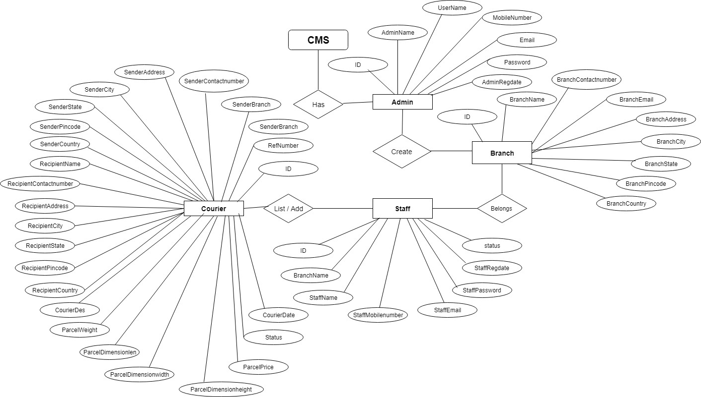

**DATABASE DESIGN**

The data in the system has to be stored and retrieved from database. Designing the database is part of system design. Data elements and data st ructures to be stored have been identified at analysis stage. They are structured and put together to design the data storage and retrieval system.

A database is a collection of interrelated data stored with minimum redundancy to serve many users quickly and efficiently. The general objective is to make database access easy, quick, inexpensive and flexible for the user. Relationships are established between the data items and unnecessary data items are removed. Normalization is done to get an internal consistency of data and to have minimum redundancy and maximum stability. This ensures minimizing data storage required, minimizing chances of data inconsistencies and optimizing for updates. The MS Access database has been chosen for developing the relevant databases.

**Courier Management System (cmsdb) contains 5 MySQL tables : tbladmin table Structure :** This table store the login details of admin.

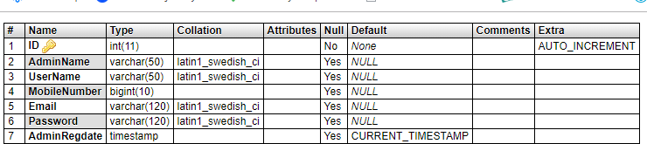

**tblbranch table Structure :** This table store the branch details**.**

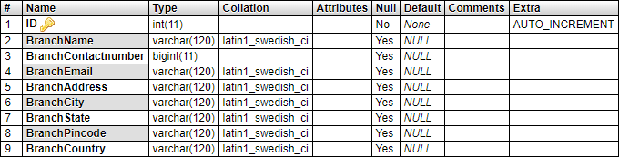

**tblstaff table Structure :** This table store the staff login and personal details**.**

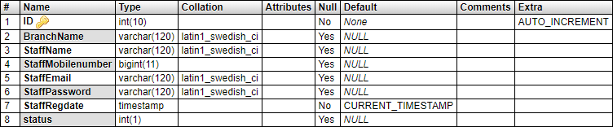

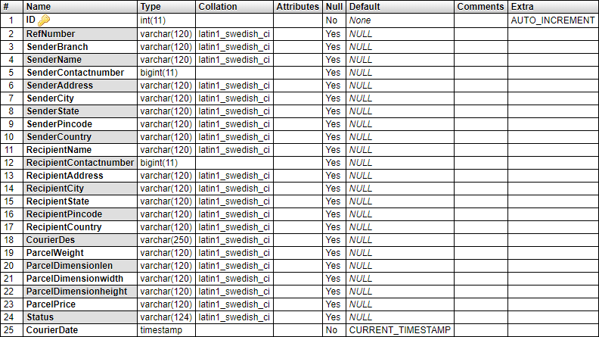**tblcourier Table Structure :** This table store the sender , recipients and courier details.

**tblcouriertracking Table Structure :** This table store the courier movement history.

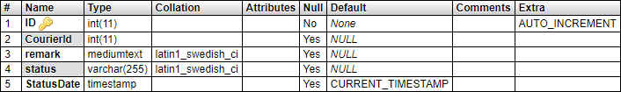

**OUTPUT SCREENS**

**Home page**

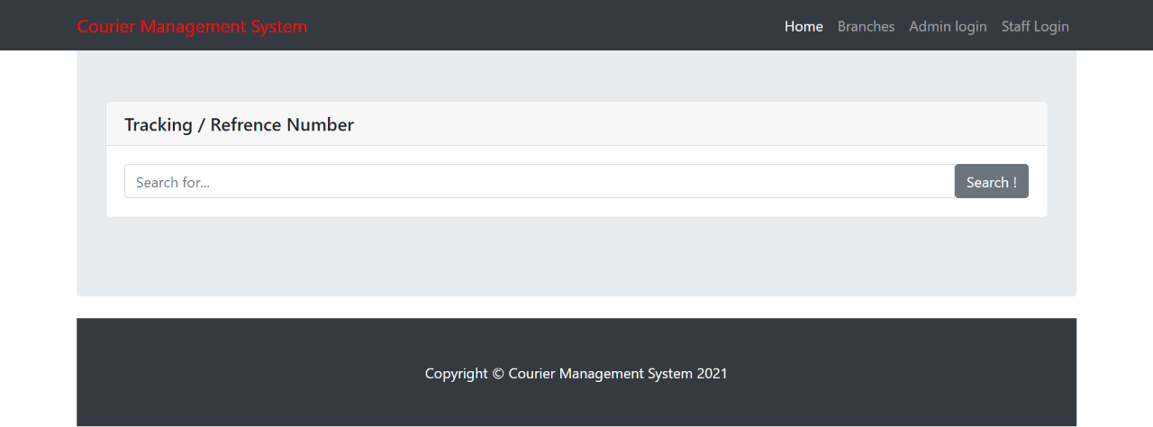

### **Admin Login**

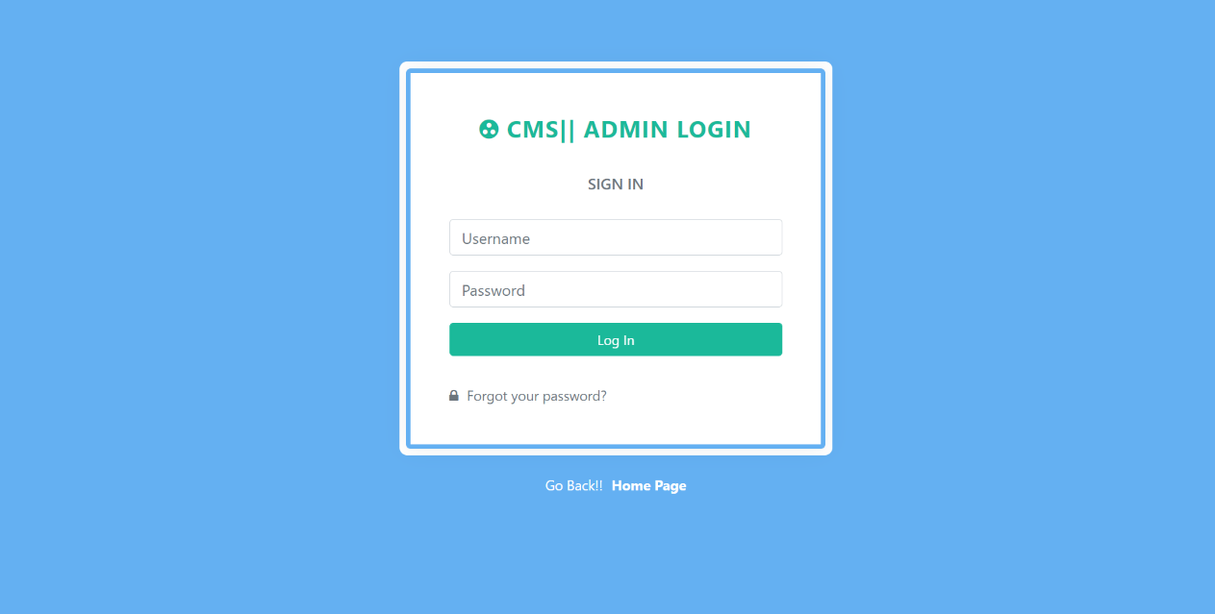

**Admin Dashboard**

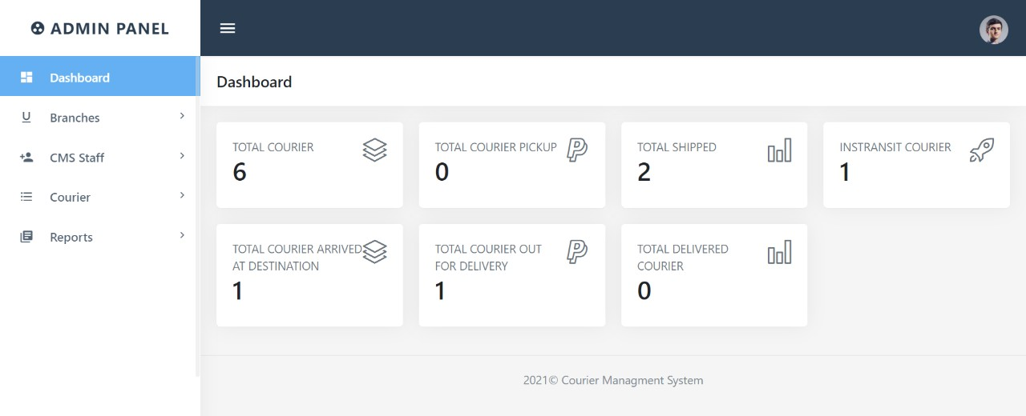

**Add Branch**

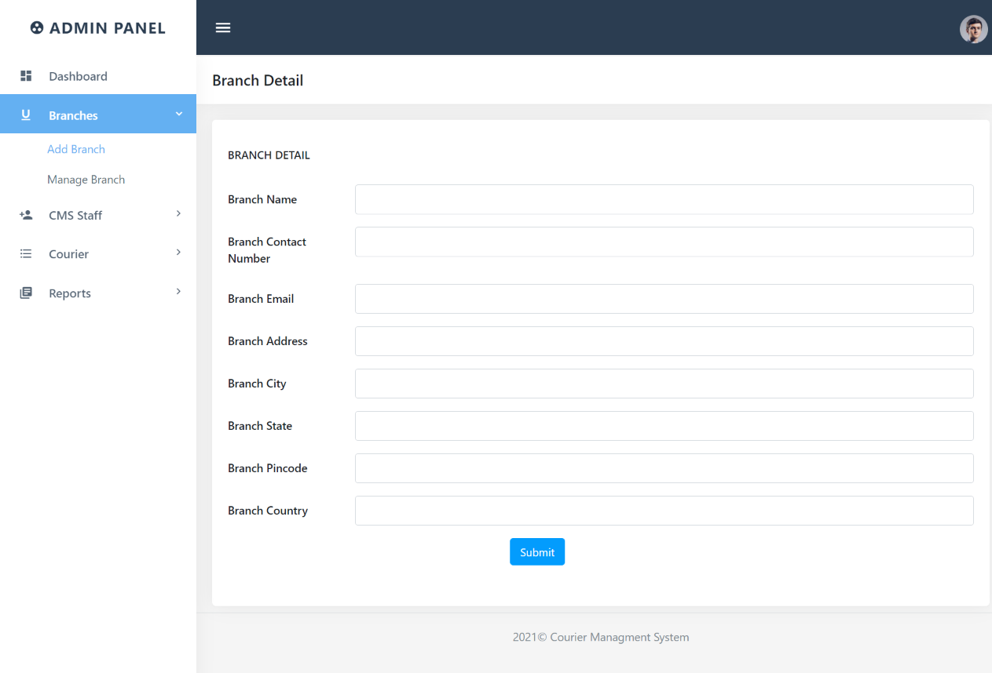

**Manage Branch Page**

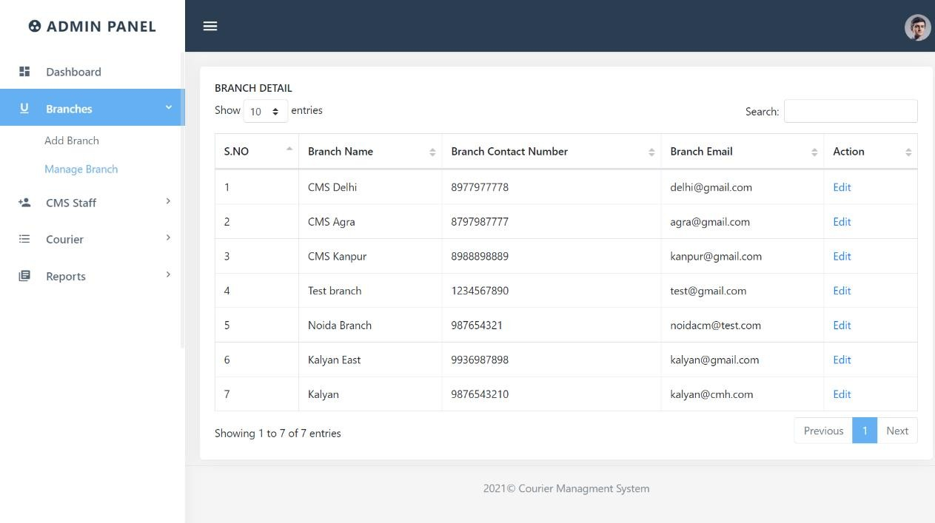

**Edit Branch Details**

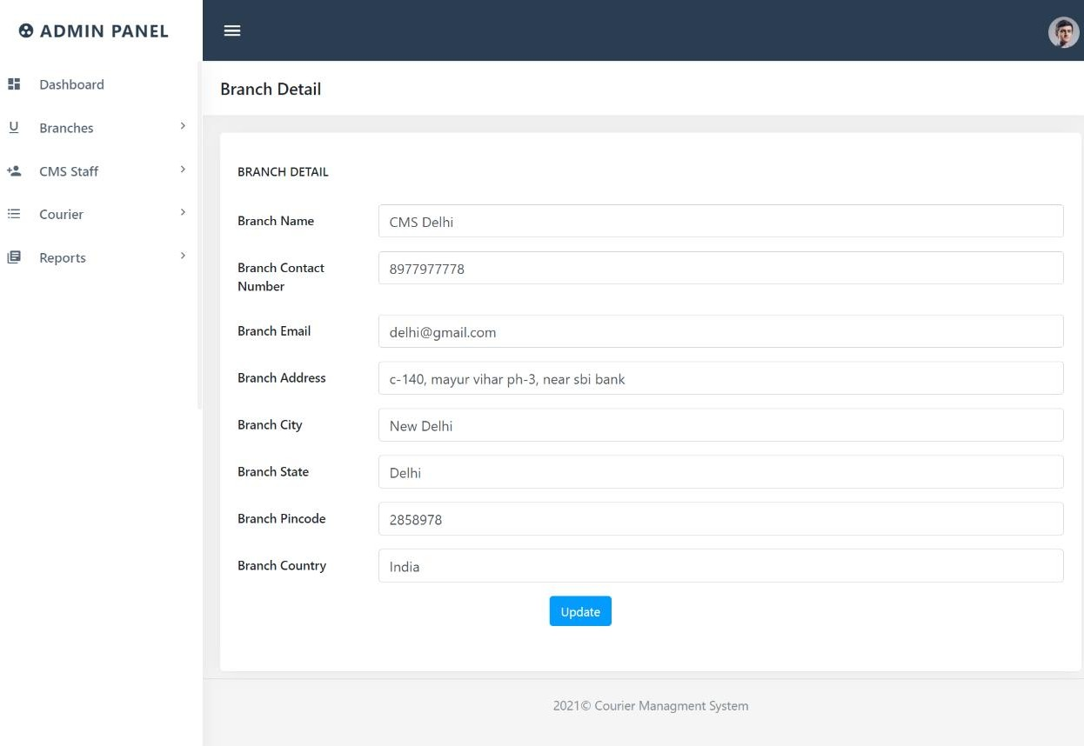

**Add Staff**

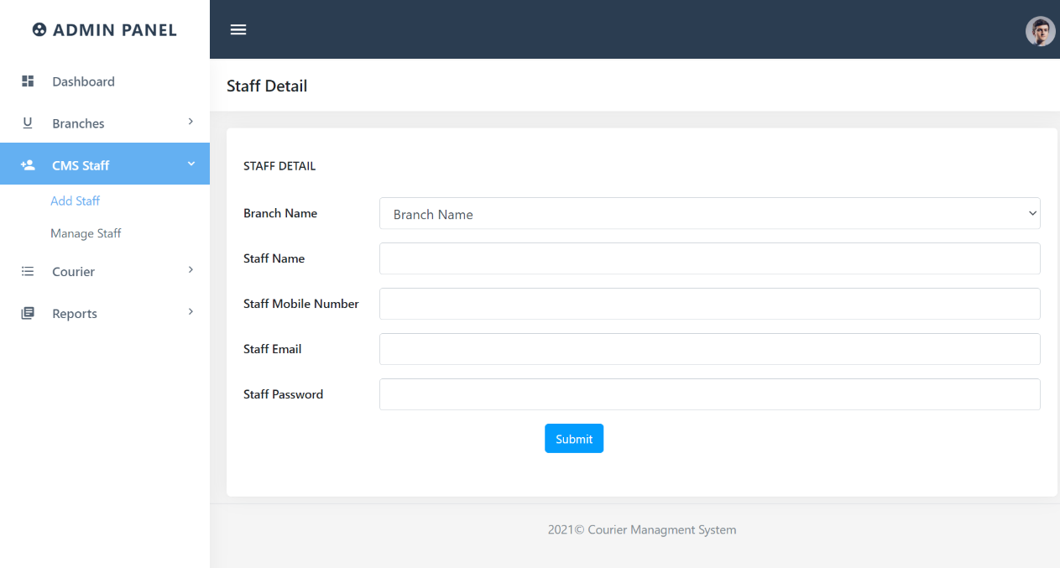

**Manage Staff**

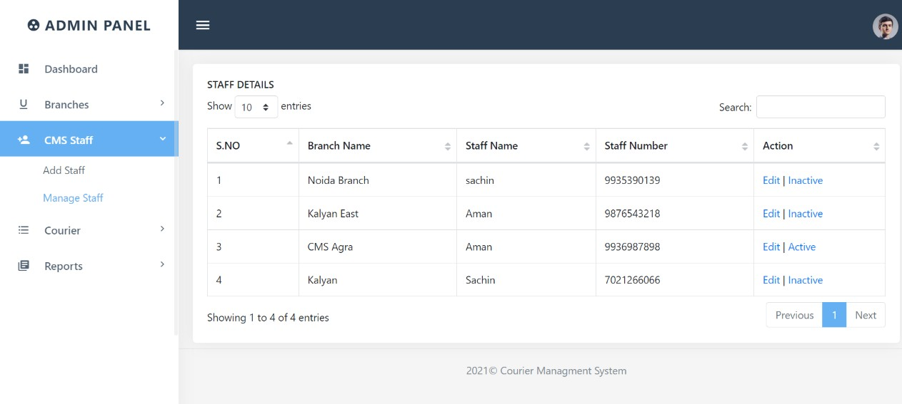

**Manage Courier**

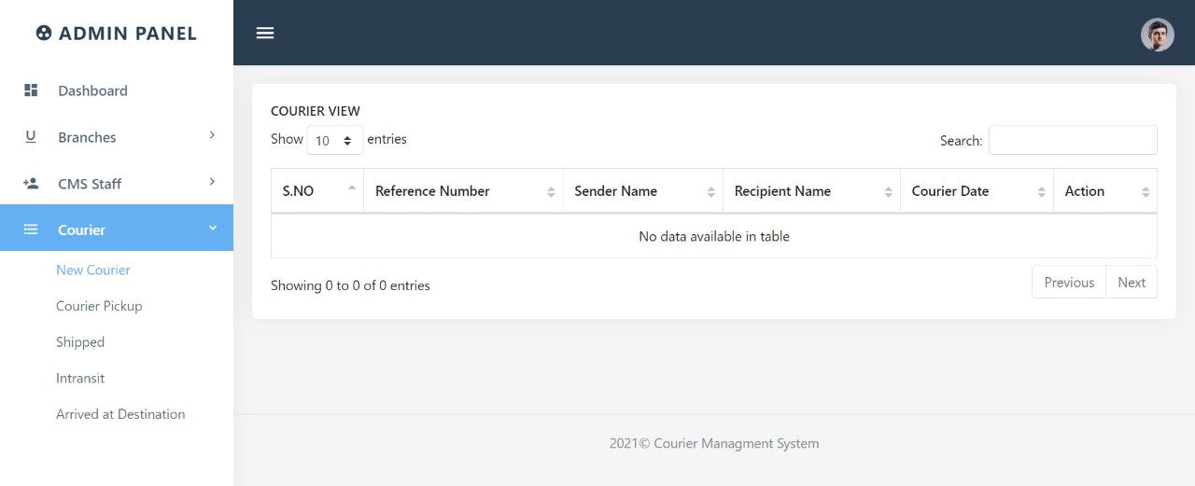

**View Courier Details**

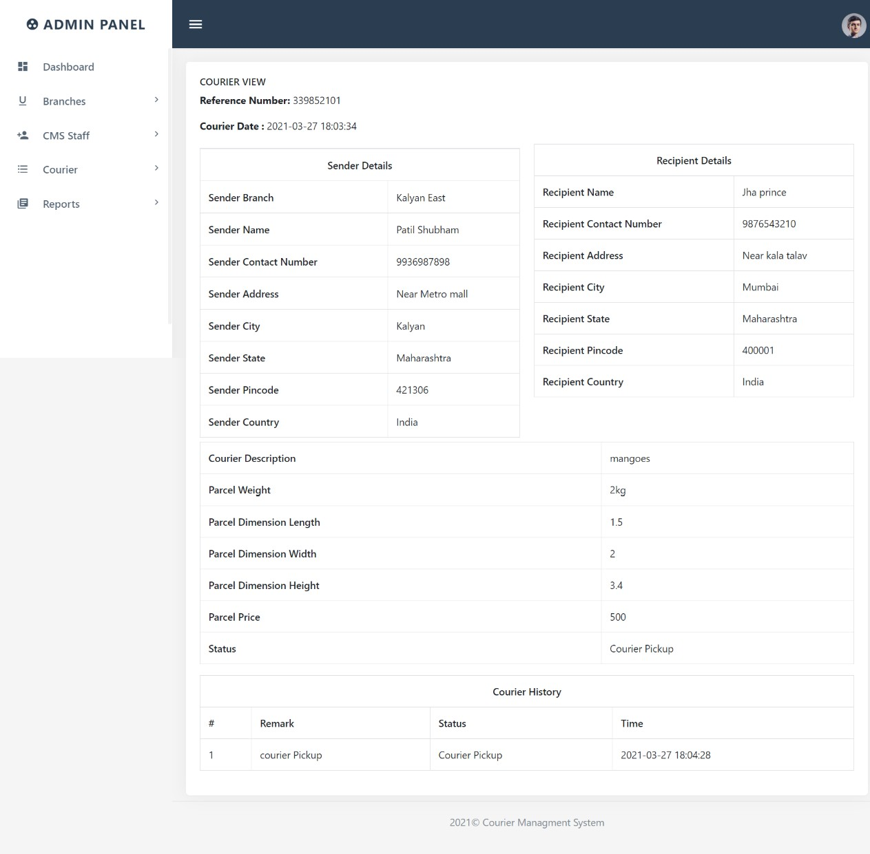

**Request Count Report detail**

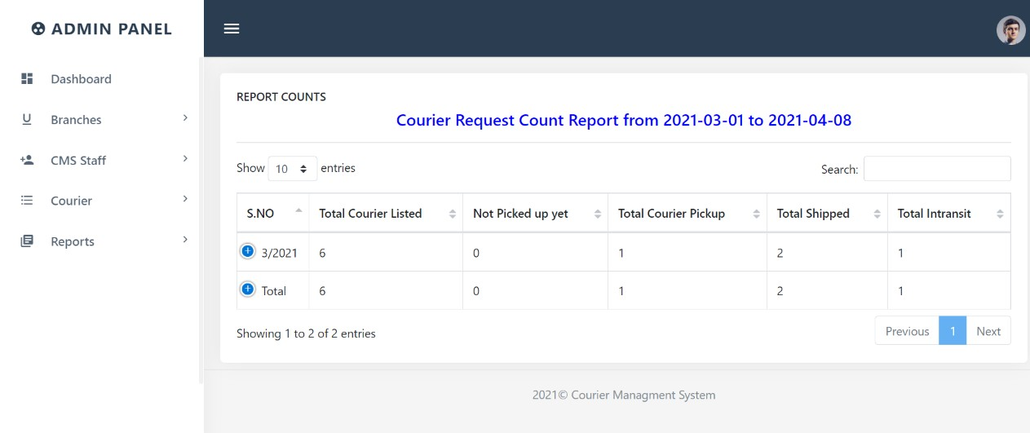

**Sales Report Details**

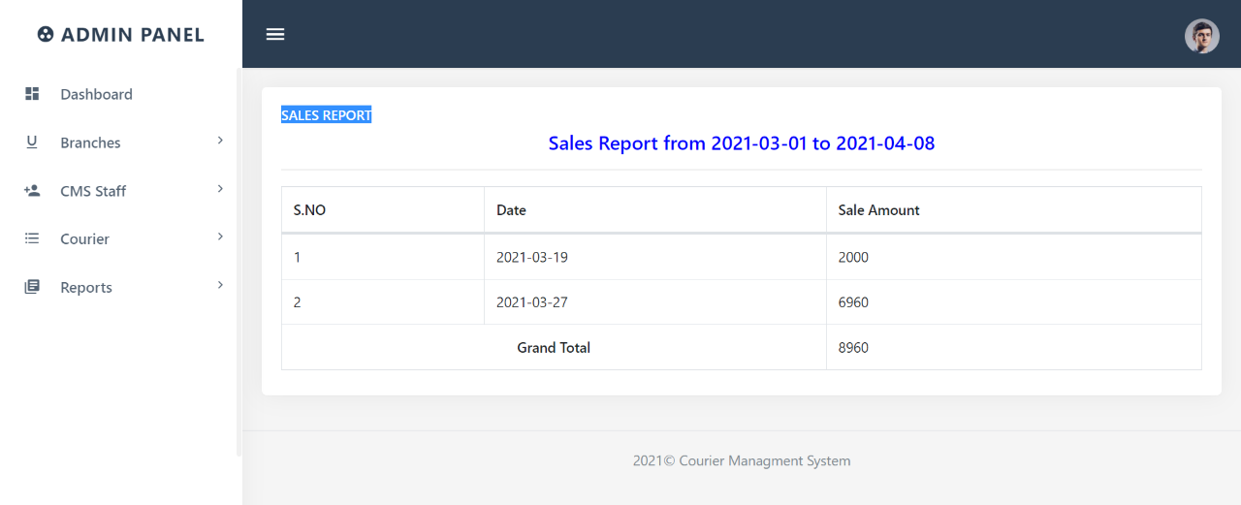

**Admin Profile**

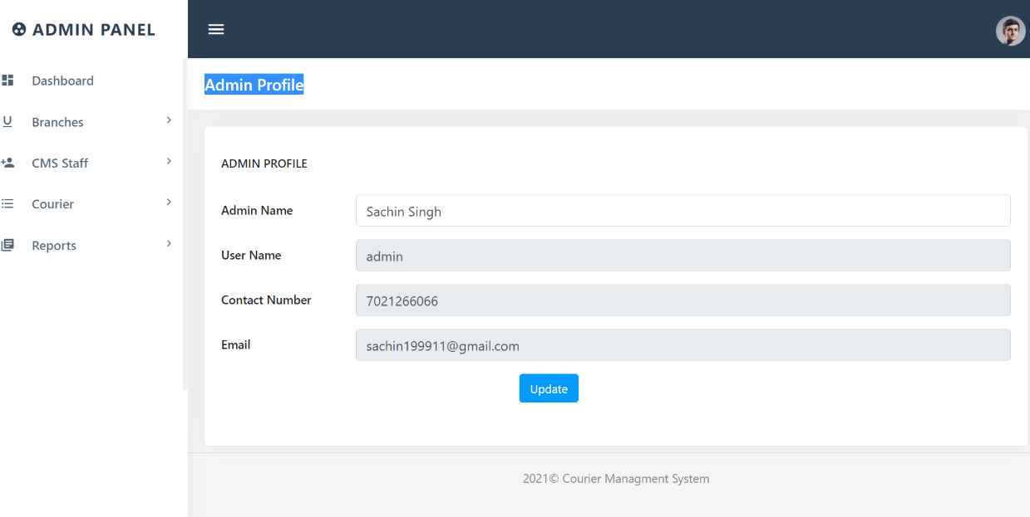

**Change Password**

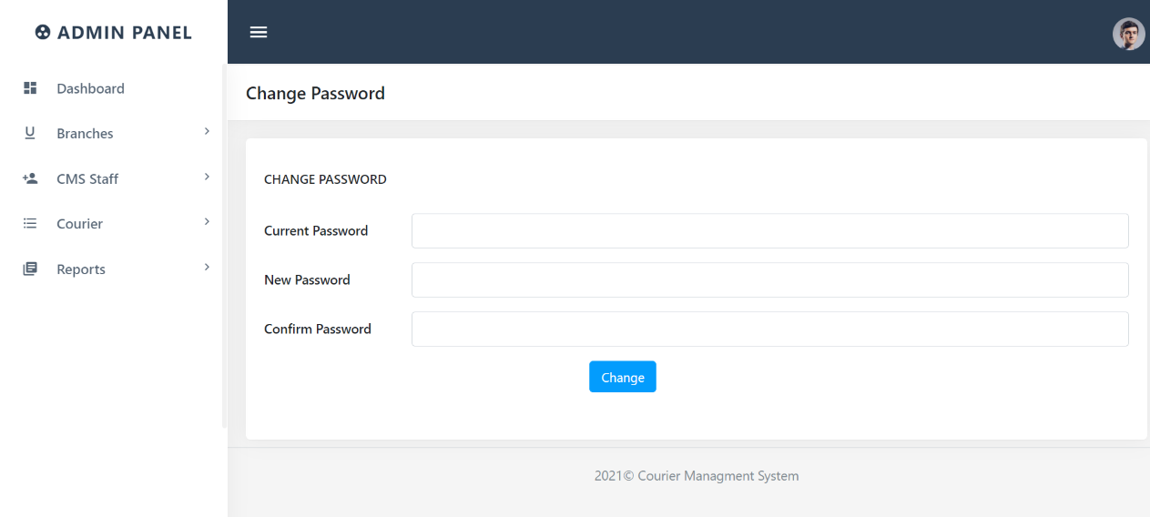

**Admin Forgot Password**

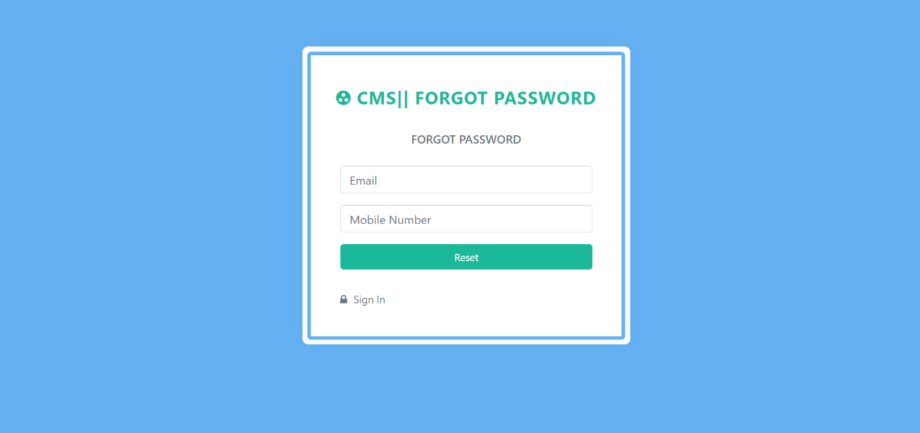

**Admin Reset Password**

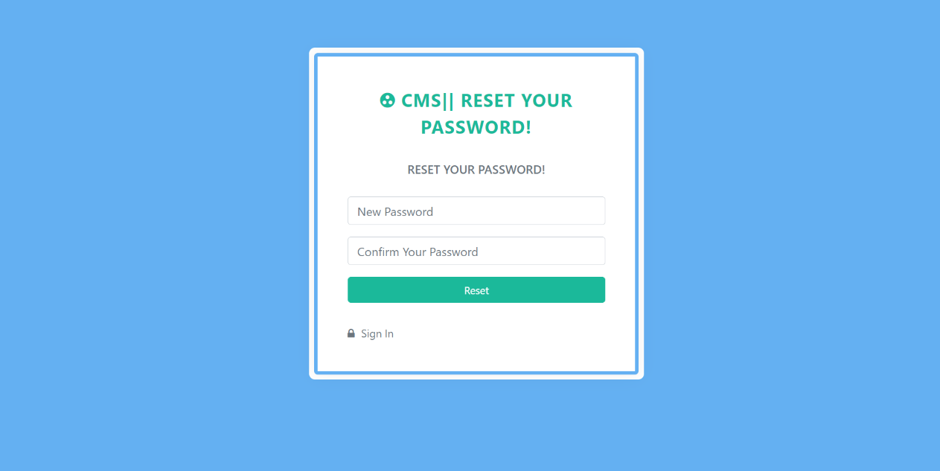

**Staff Dashboard**

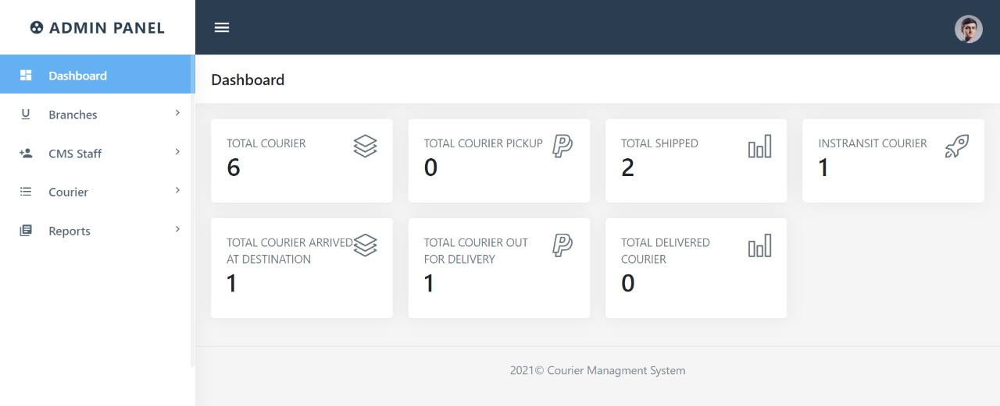

**Courier Detail Form**



**Manage Courier**



**View Courier Details**



**Courier Action**

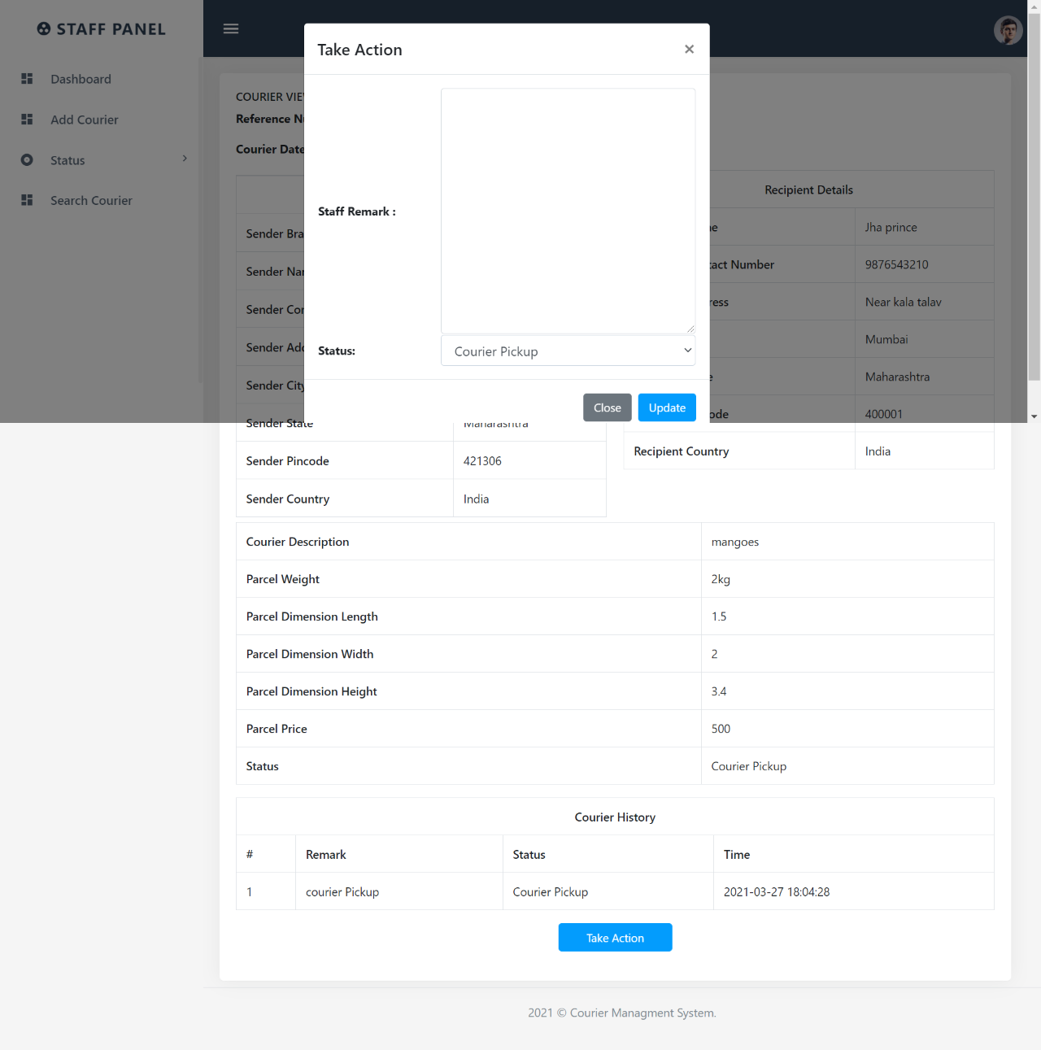

**Search Page**

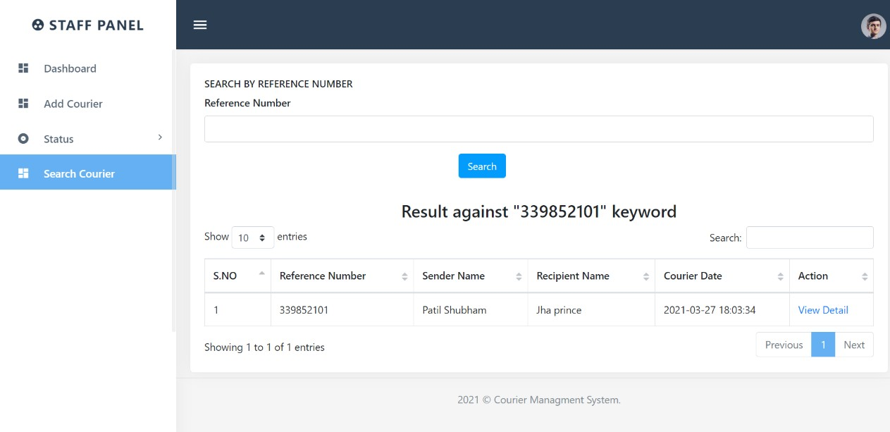

**Staff Profile**

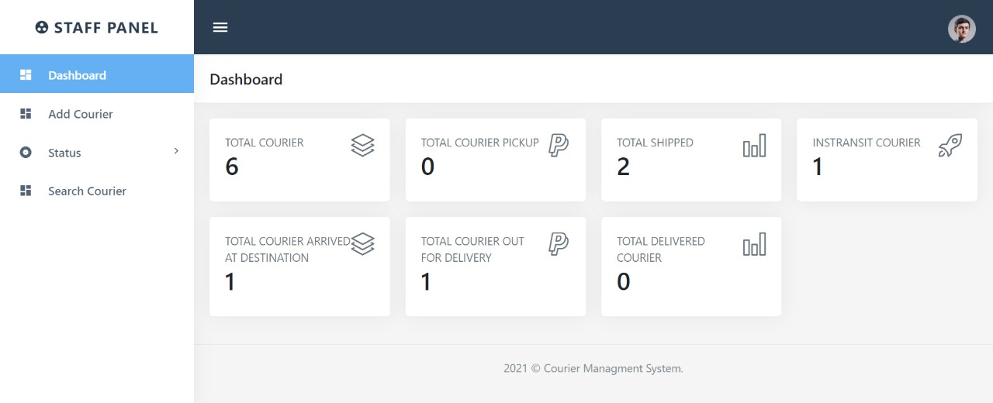

**Change Password**

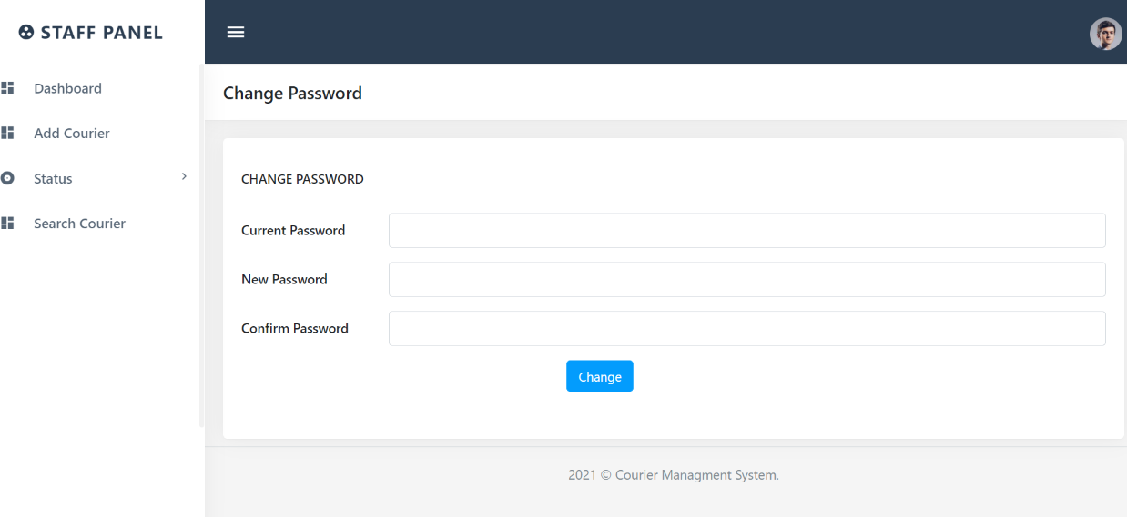

**Staff Forgot Password**

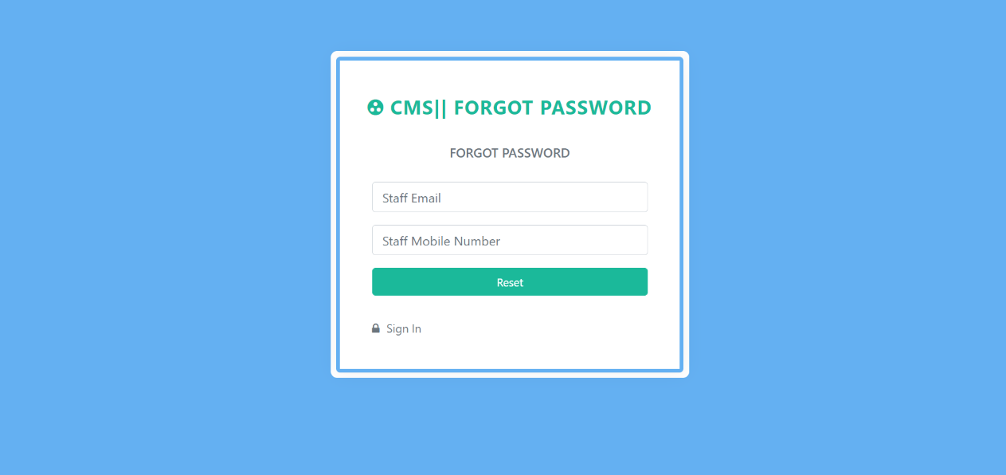

**Staff Reset Password**

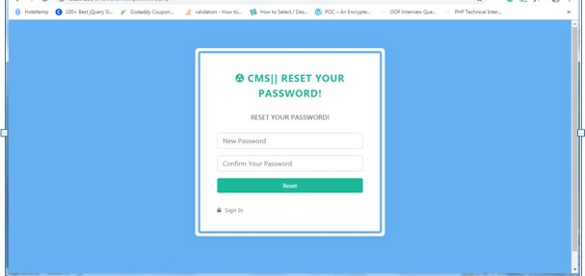

**PROJECT TESTING**

**Software Testing Strategies**

Testing is a set of activities that can be planned in advanced and conducted systematically. A strategy for software testing must accommodation low-level tests that are necessary to verify that a small source code segment has been correctly implemented as well as high-level tests that validate major system functions against customer requirements

There are three types of testing strategies

1. Unit test
2. Integration test
3. Performance test

**Unit Testing:**

Unit testing focuses verification efforts on the smallest unit of software design module. The unit test is always white box oriented. The tests that occur as part of unit testing are testing the module interface, examining the local data structures, testing the boundary conditions, execution all the independent paths and testing error-handling paths.

**Integration Testing:**

Integration testing is a systematic technique or construction the program st ructure while at the same time conducting tests to uncover errors associated with interfacing. Scope of testing summarizes the specific functional, performance, and internal design characteristics that are to be tested. It employs top-down testing and bottom-up testing methods for this case.

**Performance Testing:**

Timing for both read and update transactions should be gathered to determine whether system functions are being performed in an acceptable timeframe.

**CONCLUSION**

The entire project has been developed and deployed as per the requirements stated by the user, it is found to be bug free as per the testing standards that is implemented. Any specification-untraced errors will be concentrated in the coming versions, which are planned to be developed in near future. The system at present does not take care off the money payment methods, as the consolidated constructs need SSL standards and are critically to be initiated in the first face, the application of the credit card transactions is applied as a developmental phase in the coming days. The system needs more elaborative technicality for its inception and evolution.

**BIBILIOGRAPHY**

**For PHP**

* <https://www.w3schools.com/php/default.asp>
* <https://www.sitepoint.com/php/>
* <https://www.php.net/>

**For MySQL**

* <https://www.mysql.com/>
* [http://www.mysqltutorial.org](http://www.mysqltutorial.org/)

**For XAMPP**

* <https://www.apachefriends.org/download.html>